**Unit 3: Linear Equations and Inequalities**

**Lesson 5: Solutions and Graph of Linear Inequalities**

**Objectives:**

* **Students can identify the solution for linear inequalities.**
* **Students can graph half planes for linear inequalities.**
* **Students can write linear inequality for a half plane graph.**

**Agenda:**

* **Warm Up: Linear Inequalities’ Definition**
* **Notes: Solution and graph of Linear Inequalities**
* **Practice: Applied problems**

**Vocabulary:**

* **Linear inequalities, Half plane, Dotted vs Solid line, Shaded area, boundary lines.**

**Focus Questions:**

1. **Why is the solution for inequality represented by half-plane?**
2. **Why do we use dotted and solid lines to represent an inequality?**
3. **What does the shaded area above or below the line represent?**

**Web Support:**

- <https://www.youtube.com/watch?v=un1o0kGA-lE> (First 5 minutes)

- <https://www.khanacademy.org/math/algebra/two-variable-linear-inequalities/graphing-inequalities/v/graphing-linear-inequalities-in-two-variables-3>

**Web Practice:**

* [**https://www.ixl.com/math/algebra-1/does-x-y-satisfy-the-inequality**](https://www.ixl.com/math/algebra-1/does-x-y-satisfy-the-inequality)
* [**https://www.ixl.com/math/algebra-1/linear-inequalities-solve-for-y**](https://www.ixl.com/math/algebra-1/linear-inequalities-solve-for-y)

**Homework: Unit 3 test in two classes next Class: Work on study guide portfolio. (All corrections are due before the next unit test)**

|  |  |  |  |
| --- | --- | --- | --- |
| Less than | Less than or equal to | Greater than | Greater than or equal to. |

**Warmup:**

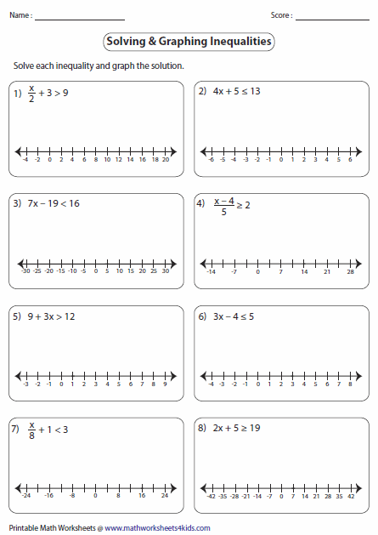

**Solving and graphing linear Inequalities in 2 variables.**

A linear inequality is an inequality which involves a linear function. A linear inequality looks exactly like a linear equation, with the inequality sign replacing the equality sign.

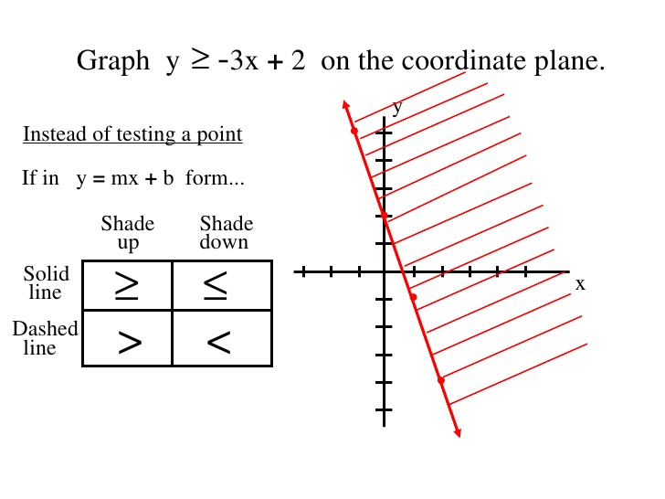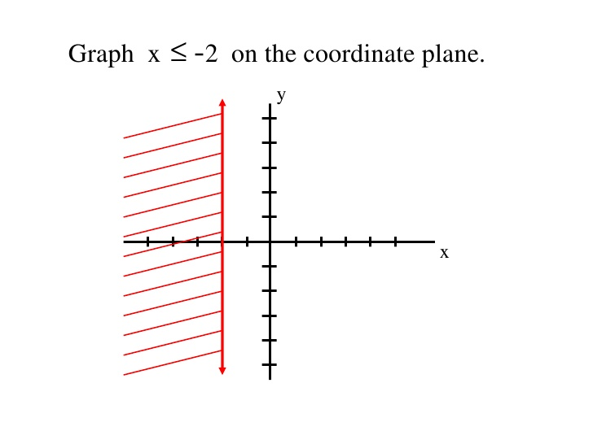

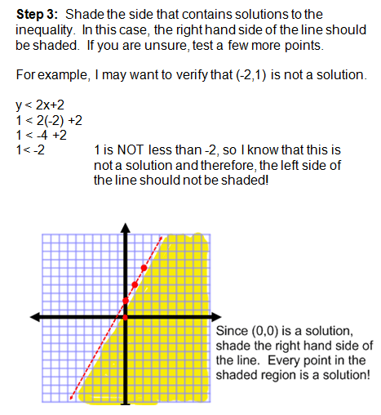

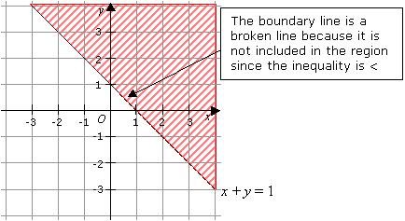

**Practice: Answer the following questions based on the following inequality:**

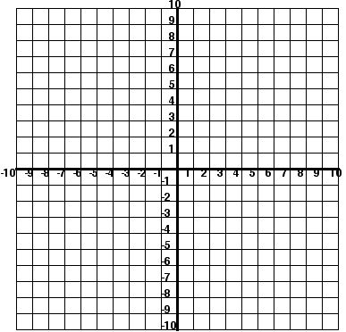 1. $2x-y≥-3$

1. What are **the parameters** of this inequality?
2. Graph the half plane for this inequality
3. Check by picking one point on the shaded region.

2. Given the inequality in the standard form: answer the following:

* 1. What are **the parameters** of this inequality?
  2. Graph the half plane for this inequality
  3. Name a solution points from the shaded region
     1. Special cases: Graph the half-plane for each inequality& state the slope for each





$y=4$ $y<4$ $x=-5$ $x≥-5$

When am I ever going to need this?  
Richard can spend **at most** $28.25 on snacks for a party. Carrots (x) cost $2.50 per package and grapes (y) cost $3.75 per bag.

1. Write a linear inequality to describe the situation.
2. If Richard decides to buy 3 bags of carrots, what is the maximum number of bags he can buy of grapes?

**Name: ______________ Date: _____**

**Homework 3-5 inequalities in two variables.**

|  |
| --- |
| Write the inequality in the slope intercept form for each wit the correct inequality symbol.  http://mathwithlarry.com/lessons/lessonimages/cartesian6.jpg    http://www.ck12.org/flx/show/cover%20page/ed2284e5400370002536904de217359e-201410281414517325334939-201410281414519444380705.pnghttp://www.algebrahomework.org/articles_imgs/586/graphi29.gif |

**2)** Alisson would like to give $5.13 gift cards (x) and $4.29 teddy bears (y) as party favors. Allison has $226 to spend on party favors.

a. Write a linear inequality to find the number of gift cards and teddy bears Allison could purchase.

1. If Allison wants to pay 12 teddy bears, what is the maximum number of gift cards she can purchase?
2. Write the equation of line whose y-intercept is -1 and slope is ¾.
3. **= _____** **= _______ equation = ___________**

**Bonus!!!!!!!!!!!!!!!!!!!!!!!!!!!!!!!!!!!!!!!!!!!!!! Graph and shade**

|  |  |  |
| --- | --- | --- |
| * http://www.cod4central.com/images/grid.jpgFind a point in the solution set. | http://www.cod4central.com/images/grid.jpg   * Find a point in the solution set. | * http://www.cod4central.com/images/grid.jpgFind a point in the solution set. |

2. State whether the ordered set of numbers is a solution of the equation.

y = 3x + 1; (7, 22)

1. Graph the following equations & label:

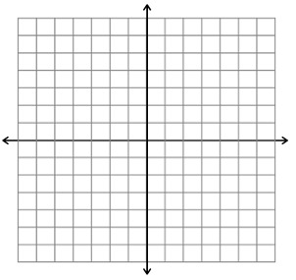a)  b) x = 6

m = __________ m = _________

b = _________ b = _________

